Turkish Economic Review www.kspjournals.org
Copyright Transfer Agreement [#06] This statement/copyright release form must accompany papers submitted to the TER Journal after appropriately filled and signed.

Number of the article
Title of the article Education-Economic Growth Nexus: A Review
Address H.No.S-1/30,Civil Quarters Peshawar
Email economist95@hotmail.com
Tel. +923339158304
Country Pakistan
The author(s) warrant(s) that:
a) The submitted manuscript is his/her/their own original work;
b) All authors participated in the work in a substantive way and are prepared to
take public responsibility for the work;
c) All authors have seen and approved the manuscript as submitted;
d) The manuscript has never been published before or is not at the stage of
evaluation in another Journal;
e) The text, illustrations, and any other materials included in the manuscript do
not infringe upon any existing copyright or other rights of anyone;
f) In consideration of my/our manuscript submitted, I/we hereby grant Turkish
Economic Review the unlimited, worldwide, irrevocable royalty-free, right to
publish, use, distribute, publish, license, transmit, display, exhibit, record, store,
translate, digitize, broadcast, reproduce and archive, in any format or medium,
whether now known or hereafter developed
However, reproduction, posting, transmission or other distribution or use of the
article or any material contained therein, in any medium as permitted hereunder,
requires a citation to the Journal and appropriate credit to Turkish Economic
Review as publisher, suitable in form and content as follows: Title of article,
author(s), journal title and volume/issue, Copyright© year. All materials related to
manuscripts, accepted or rejected, including photographs, original figures etc., will
be kept by Turkish Economic Review for one year following the editor’s decision.
These materials will then be destroyed.
This copyright form must be signed by all authors. Separate copies of the form
(completed in full) may be submitted by authors located at different institutions;
however, all signatures must be original

Author’s (or Corresponding Author):
Full Name
Dr.Jangraiz Khan
Signature
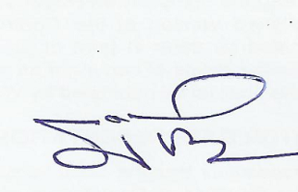
Date
08/06/2015

